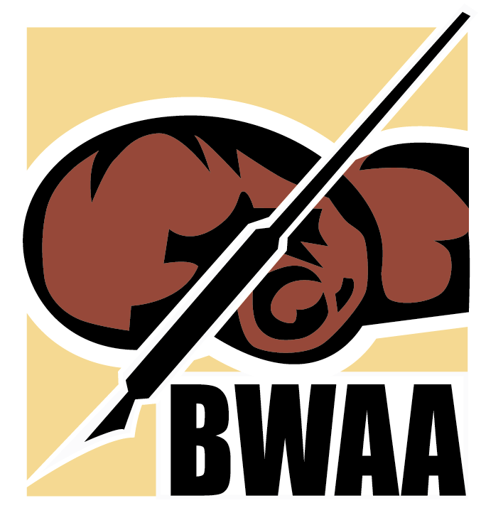

Boxing Writers Association of America
100th Annual Awards Dinner

WEDNESDAY, APRIL 30, 2025

Edison Ballroom
240 West 47th Street, New York, NY

Cocktails: 6:00 PM
Dinner and Awards: 7:15 PM

● BUSINESS ATTIRE REQUESTED ●

TICKETS
$275 per Person - $2,750 per Table of Ten
Includes Open Bar Throughout the Evening, Cocktail Reception, Dinner, and Gift Bag

A LIMITED NUMBER OF SPECIAL VIP TICKETS ARE AVAILABLE
$500 per person
$5,000 per table of ten
Includes Premium Seating at Dinner and Special VIP Gift

Payment via Mastercard/Visa, AmEx, Check, Money Order, or PayPal
must be received by April 20, 2025
PayPal: “Boxing Writers Association of America” or Graham@bwaa.org
Send checks to:
BOXING WRITERS ASSOCIATION OF AMERICA
c/o 1215 76th Street, Brooklyn, NY 11228

For event information, including Sponsorship, Ads and Tickets:
BWAA Website: www.bwaa.org

Gina Andriolo: 917-312-6418
email: ginaandcom@aol.com

Joe Santoliquito:
email: jsantoliquitoBWAA@yahoo.com

